**Assignment 2.2**

**Task 3:**

Create a file max-temp.txt in local FS

Put some 10-15 records of date and temperature

Example: dd-mm-yyyy, temperature

Example:

10-01-1990 , 10

10-01-1991 , 20

Move this file to HDFS at /user/acadgild/hadoop

First checking ‘max-temp.txt’ file in local fs:

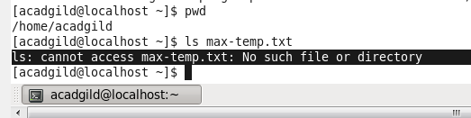

Creating a file ‘max-temp.txt’ in local FS:

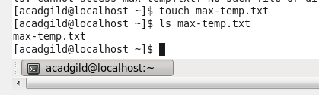

Adding 10-15 records of date and temperature in “max-temp.txt”:

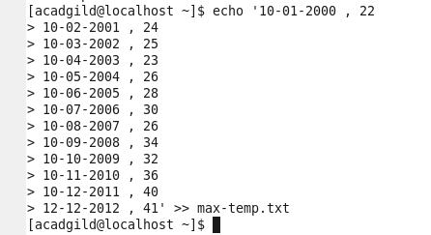

Records entered in to ‘max-temp.txt’ file in to local file system

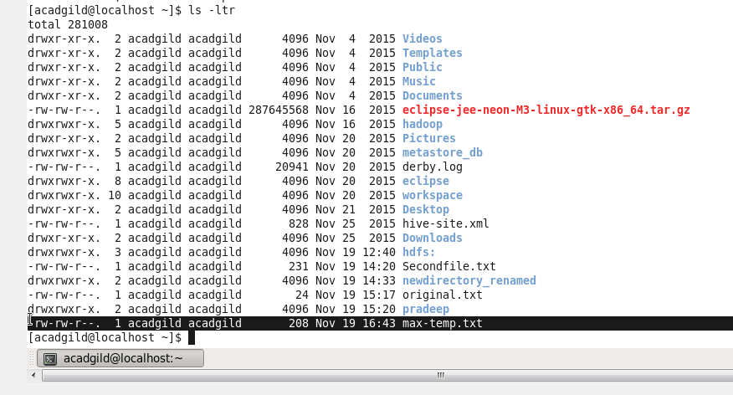

‘max-temp.txt’ is available in local file system and few records added in to this file, as shown in below screen:

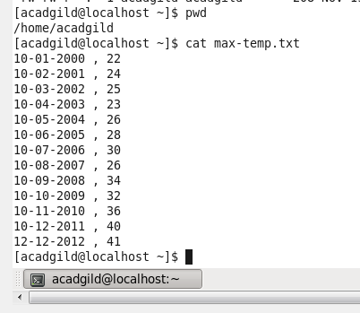

Moving ‘max-temp.txt’ file from local file system to HDFS at /user/acadgild/hadoop:



‘max-temp.txt’ file copied successfully from local file system to **/user/acadgild/hadoop**

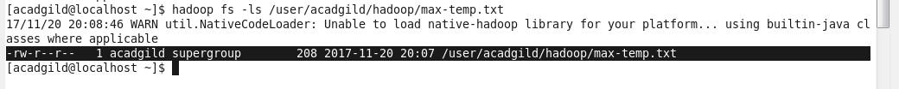

**Task4:**

Changing the permission of the file /user/acadgild/hadoop/max-temp.txt’ such that only owner and group members have full control over this file.

Full control = read, write and execute

Others not having control over the file – so it’s **chmod 770**



Now it can be observed that permission of file is changed – such that only owner and group members have full control over the file and others do not have any control over the file:

